Hosanna

(C#m E F#m G#m)

E C#m
I see the king of glory coming down the clouds with fire
F#m G#m C#m
The whole earth shakes, the whole earth shakes
E C#m
I see his love and mercy washing over all our sin
F#m B
The people sing, the people sing

G#m A B C#m
Hosan--na, Hosan--na
A C#m B
Hosanna in the highest
G#m A B C#m
Hosan--na, Hosan--na
A B C#m (E F#m G#m)
Hosanna in the highest

E C#m
I see a generation rising up to take their place
F#m G#m C#m
With selfless faith, with selfless faith
E C#m
I see a near revival starting as we pray and seek
F#m B
We’re on our knees, we’re on our knees

A B
Heal my heart and make it clean
E C#m
Open up my eyes to the things I see
A B C#m
Show me how to love like You have loved me
A B
Break my heart for what breaks Yours
E C#m
Everything I am for your kingdom cause
A B E
Used by Permission. CCLI #11103902 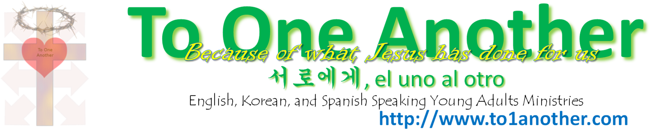
As I walk from earth into eternity

